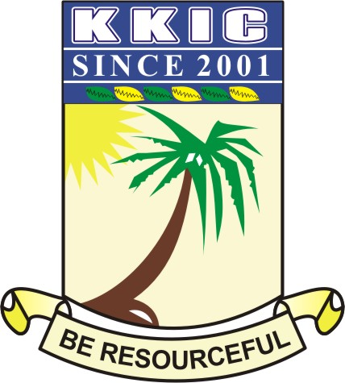

|  |  |  |  |  |  |
| --- | --- | --- | --- | --- | --- |
| **NAME** |  | | | | |
| **SUBJECT** | **CIVIC EDUCATION (THEORY)** | **CLASS** | **SS 2** | **DURATION** | **1 HOUR** |

**SECTION B: THEORY (40Marks)**

**Answer question 1 and any other three questions of your choice**

1. Write short notes on the following skills necessary for resolving inter-communal conflicts.

* Arbitration
* Mediation
* Special peace-keeping taskforce
* Compensation **8 MARKS**

(b) Mention four function of political parties. **2 MARKS**

1. (a) Discuss 5 constraints of good parenthood.  **5MARKS**

(b) Mention skills that promote interpersonal relationship **5MARKS**

1. Write 4 characteristics of communal society **4 MARKS**

(b) Inter-communal relationship has various activities. Discuss any 3 activities. **6 MARKS**

1. (a) Write the full meaning of the following:
2. NAFDAC
3. NDLEA
4. NSCDC
5. LASTMA **4 MARKS**

(b) List 6 roles of LASTMA **6 MARKS**

1. (a) Discuss any 5 types of interpersonal relationship **5 MARKS**

(b) Define the term inter-communal relationship **2 MARKS**

(c) List 3 importance of employment **3 MARKS**

6. Explain four importance of responsible parenthood to national development **4 MARKS**

(b) List 6 duties of pedestrians. **6 MARKS**